Teen and Young Adult Job Seminar

Topics we will be covering:

Where: Lake Shore High School’s library

When: September 25th at 5:00 pm

* 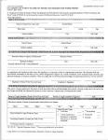Form W-4
* Form W-2
* Form 1-9
* Social Security
* Work Permits .

Contact: Shelby Lane

Phone: 586-777-7474

Email: workers@gmail.com

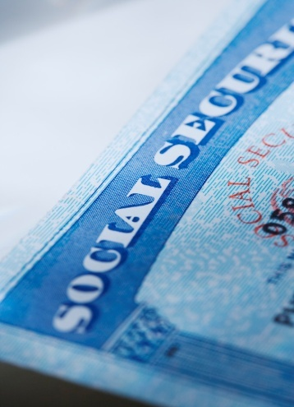

C:\Users\Parents\AppData\Local\Microsoft\Windows\Temporary Internet Files\Content.IE5\9YU0HLN2\MC900293646[1].wmf



Sources: [www.irs.gov](http://www.irs.gov) and [www.socialsecurity.gov](http://www.socialsecurity.gov)