Shelby Lane
11/27/2015
Hour 2
Career Field Experience

Career Field Experience Essay
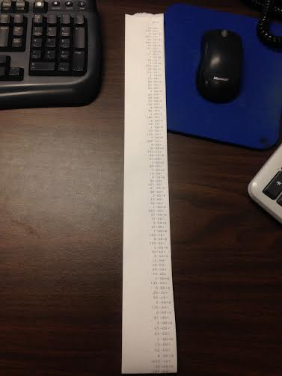
James Matthew Barrie once said, “Nothing is really work unless you would rather be doing something else”. This is the perfect quote related to my experience because if you do what you love, you will never have to work a day in your life. In my Career Field Experience class, I worked at BRS Accounting. In my opinion Career Field Experience is a unique class because it gave me the perfect hands- on experience that I wouldn’t be able to receive in a classroom. For thirteen weeks I sorted through paperwork, added things up, filed papers, worked with payroll, and so much more. While reflecting on my overall learning experience in this class, I will outline three employability skills: honesty, willingness to learn, and self motivation.
Working in an accounting office, you have to be a very honest person. People are trusting you with very personal information. This class has really been testing my creativity skills because I have to be extremely careful with what I take pictures of and post online. All of the work I do there is confidential. The company I work for is trusting me not to share any personal information.
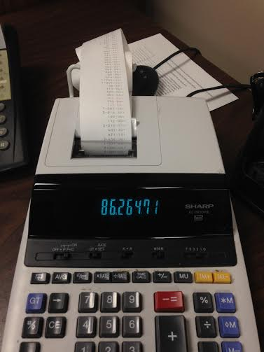
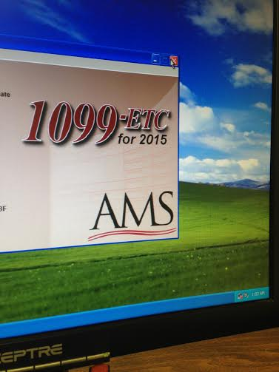
Going into this experience I needed to be willing to learn a lot of different things. I had taken two accounting classes, but the information I had learned in those classes was very different than the information I learned through the company. I was unfamiliar with the payroll software that they use, I had no previous experience with the Excel program, and I had no idea what a 10- digit calculator was. Honestly, when my manager asked me if I had experience with the calculator I thought she was asking me a trick question. Some of the programs and systems we use are not the easiest to work and it took me a while to get use to them.
Working at BRS Accounting has also improved my ability to work with little supervision. Although we are a team, everybody is working on their own project. They are always willing to help and to explain things to me but a lot of the work I do would be difficult to do with other people around. My problem solving skills have also improved from working by myself. I can no longer rely on somebody else for the right answers; I have to find them on my own.
This class has improved many skills for me and made me realize that I really do want to become an accountant. I will never forget my manager saying “if you still want to be an accountant after your experience, you will be in good shape”. They are giving me an experience I could never receive in a classroom. Because of this experience I now know for sure that I want to go to school for accounting. I would absolutely recommend this experience to a friend. It is amazing and it really helps you decide whether or not you want to do what you think you want to do.

